Social Inbound Voice & Appointment Automation
GoHighLevel | Synthflow | Voice Agent | CRM | Appointment Booking | Email

Project Overview
Built an inbound voice automation system for Brandy Social using Synthflow and GoHighLevel.
The system handles incoming calls, captures customer information, manages appointment bookings, and keeps the resulting data organized inside the CRM.
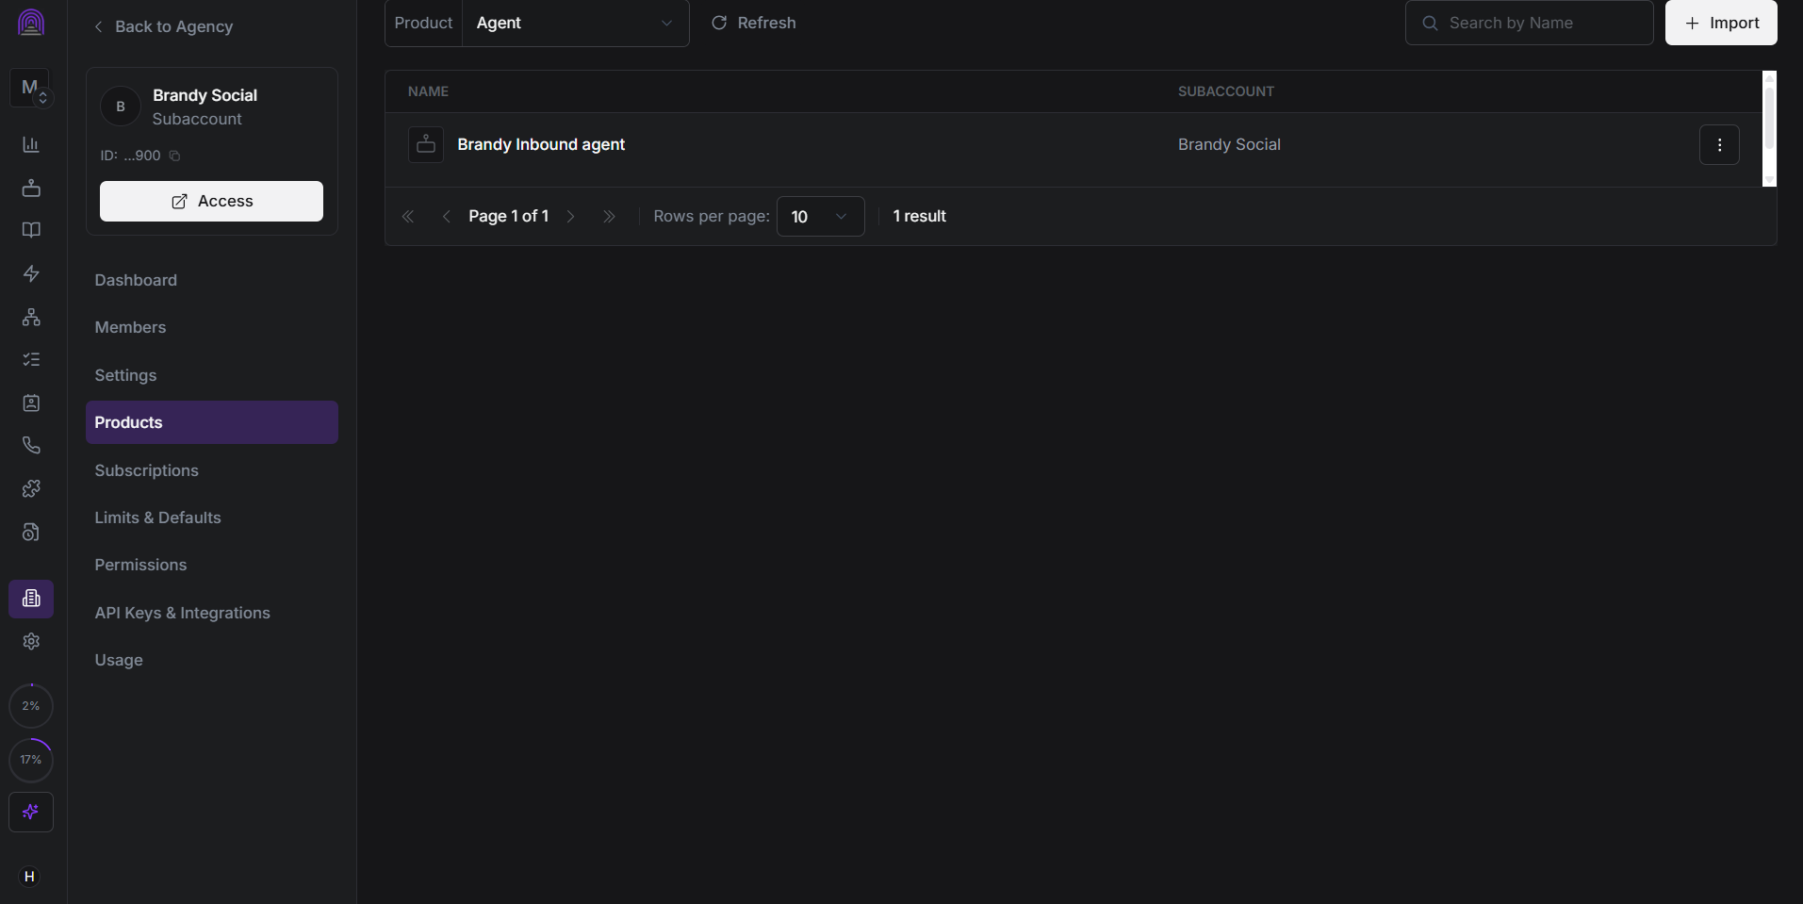
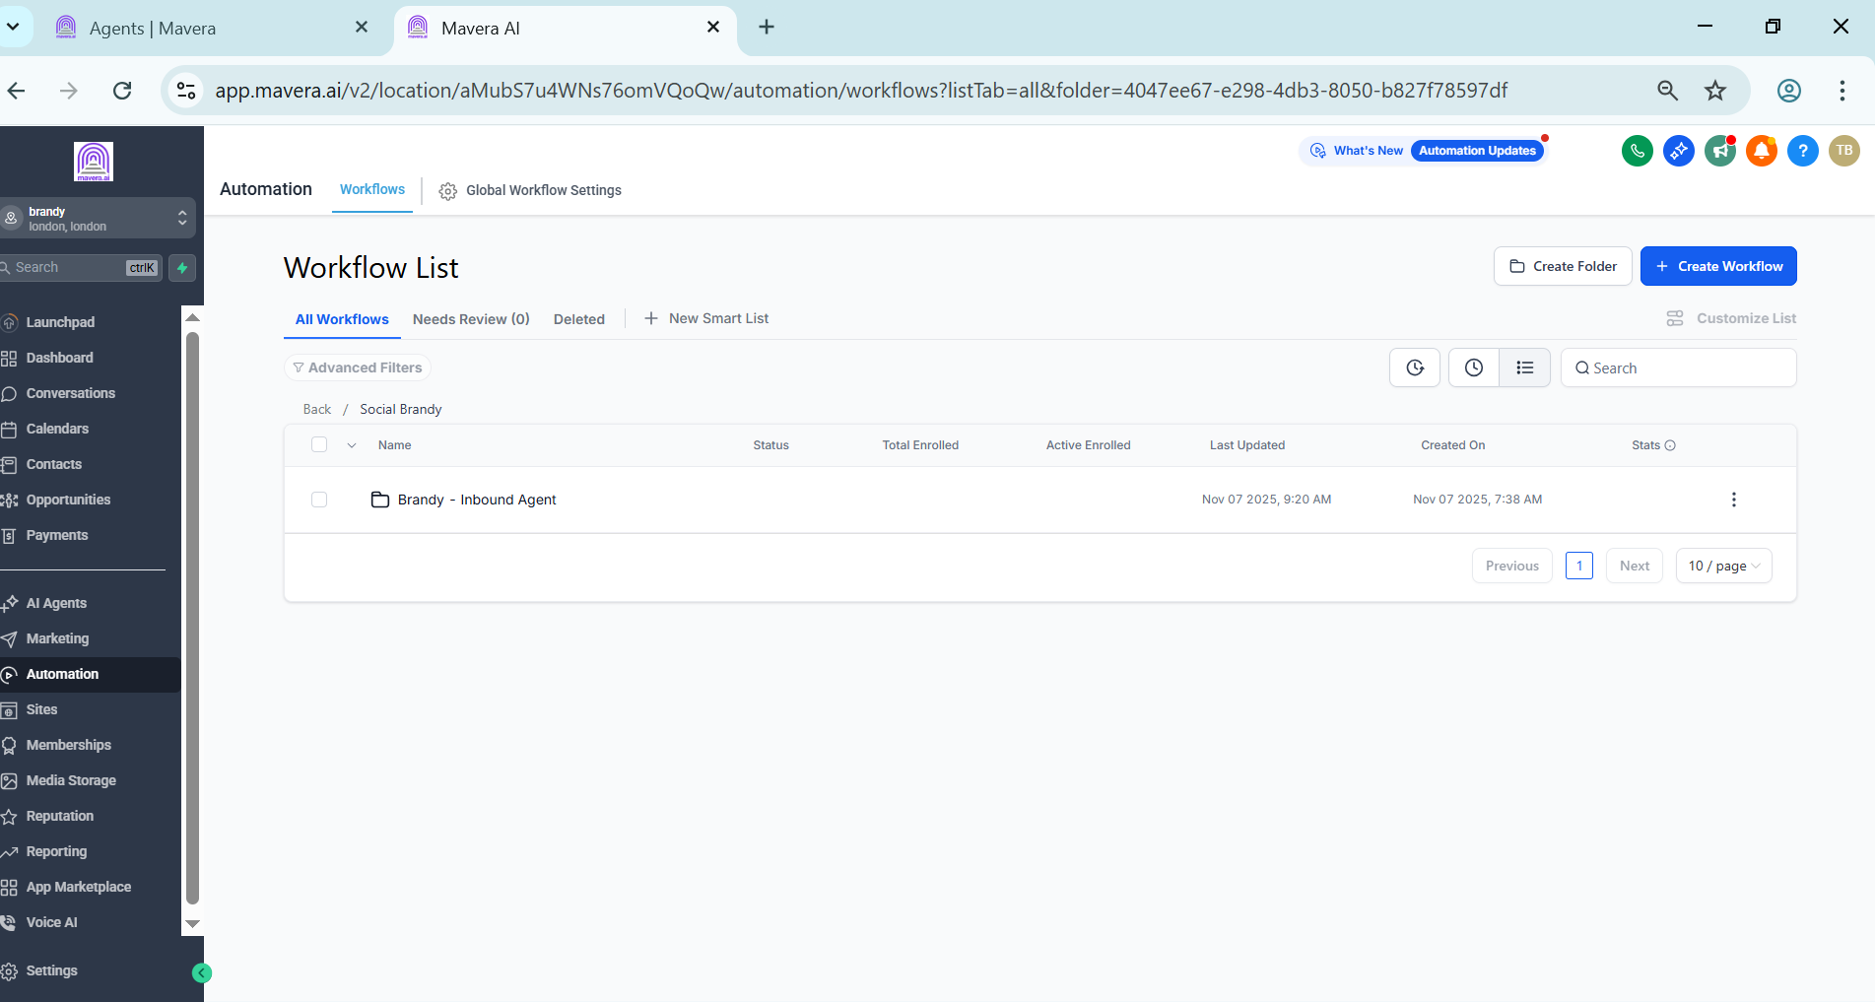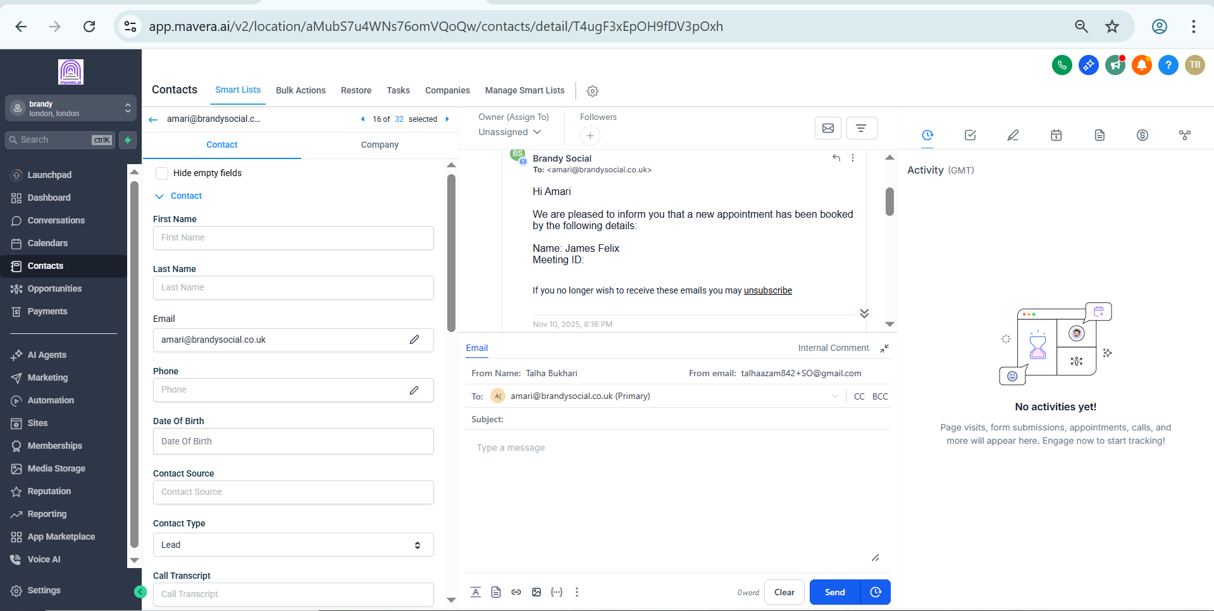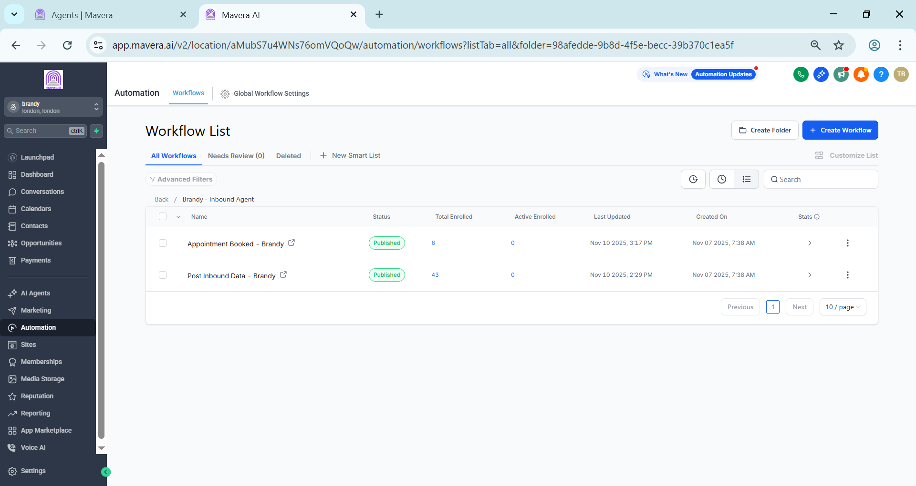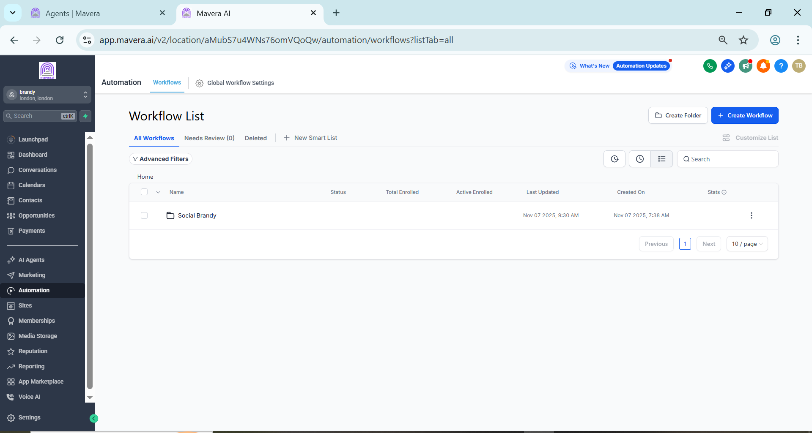

Voice Agent Setup
Configured a dedicated Brandy Inbound Agent in Synthflow and connected it with the Brandy Social GoHighLevel subaccount.
The agent handles incoming customer conversations and supports the appointment process.

GoHighLevel Workflows
The inbound setup includes:
• Brandy Inbound Agent
• Appointment Booked
• Post Inbound Data
These workflows manage the different stages of the customer journey and update the CRM accordingly.

Appointment Automation
When an appointment is booked, the workflow processes the booking information and updates the related contact record in GoHighLevel.
Post call data is also handled automatically to keep customer information organized.

Email Communication
The system uses GoHighLevel email communication for appointment related messages and customer follow ups.
Email activity is stored directly against the contact record, providing a complete view of customer interactions.

Technology
• GoHighLevel
• Synthflow
• Voice Agent
• CRM Workflows
• Appointment Booking
• Email Automation

Result
A structured inbound voice system connecting customer calls, appointment booking, post call processing, CRM updates, and email communication in one GoHighLevel setup.
The automation reduces manual handling and keeps the customer journey organized from the initial call through appointment follow up.

